**112510 SCREENSHOTS**

Gold loan leads in CRM and CRC are automated as mail

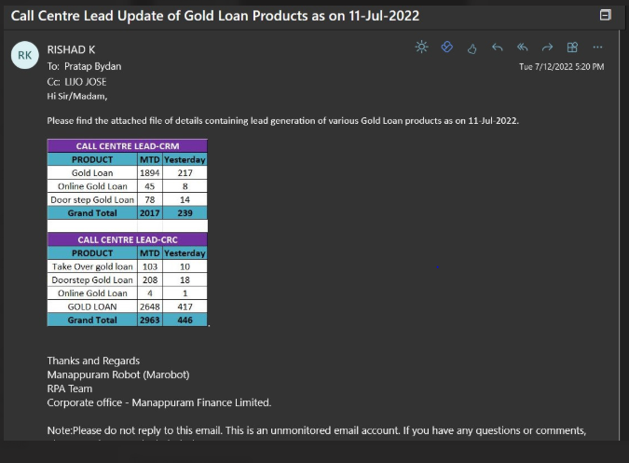

The product, MTD, yesterday and grand total details are displayed correctly in dashboard and attached in mail

